TRADEGUARD
The honest prediction matrix for retail traders
Mobile + Web Product Proposal
Confluence scanning · projected entries · live alerts · turtle-soup entries · news stand-aside
Prepared for investor / partner review — July 2026
Working prototype already built and tested (Python analysis engine, alert engine, Deriv market-data feed).

Contents

1. Executive summary
Retail trading has a trust problem. Every day, beginners hand their money to self-declared mentors, signal sellers and “account managers” who promise guaranteed returns, charge for recycled lessons, and routinely blow the accounts entrusted to them. The victim loses twice: the fee, and the capital. The tragedy is that most of what these operators claim to sell — structure, patience, and a plan — can be delivered honestly, transparently and automatically by software.
TradeGuard is that software. It is a mobile (Android) and web application that gives an ordinary trader the full prediction matrix professionals use: live prices, candlestick pattern recognition, support and resistance, supply and demand zones, fair value gaps, trendlines, projected future entry points, scheduled alerts, and a news filter that tells the user when NOT to trade. Instead of promising riches, it delivers a disciplined verdict on every chart: WAIT or ENTER — with the entry, stop-loss, target and position size computed before a single dollar is risked.
The core analysis technology is already built and tested: a Python pattern engine (peak detection, zone clustering, pattern grading, future-entry projection), a stateful alert engine, and a robust Deriv WebSocket market-data client. This proposal describes the need, the target users, the product, the architecture, the business model, and the plan to bring it to market.

The one-line pitch
Where scammers sell hope, TradeGuard sells discipline: a transparent, always-on analysis co-pilot that helps small traders make small, planned wins — and, just as importantly, avoid the losses that destroy accounts.

2. The real need: a market flooded with scammers
The idea for TradeGuard did not come from a laboratory. It came from watching what actually happens to new traders, especially across Africa, Asia and Latin America where mobile-first trading on platforms like Deriv has exploded:
- Fake mentorship — They pay for “mentorship” classes that teach generic candlestick names with no execution rules, no risk framework and no accountability.
- Signal sellers — They join paid signal groups that broadcast entries with no reasoning, no stop discipline and conveniently deleted losing calls.
- Account management fraud — They hand login credentials or funds to “account managers” who over-leverage, blow the account, and disappear — or demand more deposits to “recover” losses.
- Self-inflicted losses — Even honest beginners self-destruct: entering at the first touch of a level, trading through high-impact news, revenge trading, and risking far too much per position.

Why the scams work
Scams work because they fill a real vacuum. A new trader genuinely lacks four things: (1) the ability to read structure on a chart, (2) the patience to wait for price to come to a plan, (3) protection from entering at the worst moment, and (4) a feedback loop that tells them what actually works. Scammers pretend to supply these. TradeGuard actually supplies them — as verifiable software behavior, not personality-driven promises.

The cost of the status quo
What users pay scammers for | What they actually get | What TradeGuard delivers instead
“Mentorship” courses | Recycled pattern names, no rules | Every scan shows its reasoning: the zone, the pattern, the confluence score
Paid signals | Blind entries, hidden losses | Alerts generated by transparent logic, journaled with outcomes — wins AND losses
Account management | Blown accounts | The user keeps custody; the app only advises, sizes and warns
“Recovery” services | A second scam | Risk rules that prevent the first blow-up

3. Value proposition and target users

Value proposition
- Capital preservation first — Money saved before money made: the default verdict is WAIT. The app quantifies why now is not the moment, projects where the moment will be, and watches the market so the user does not have to.
- Better entries — Cheaper, safer entries via the turtle-soup method: the app expects the fake-out sweep of a level before entry, so users stop paying for the first touch that gets stopped out.
- Transparent reasoning — A visible confluence score (zone + pattern + trendline + fair value gap + trend bias) replaces gut feeling and guru opinions.
- News protection — An economic-news stand-aside module warns users not to enter before high-impact releases — the single most common way beginners get wiped out in seconds.
- Learning loop — Every alert and outcome is stored; the system reports the user's real statistics per pattern, per pair, per timeframe — an honest mentor that never hides a losing trade.
- A great plan, enforced — Small, planned wins with fixed fractional risk (0.5–2% per trade) and minimum 1:2 reward-to-risk enforced in the position sizer.

Target users
Persona | Situation | What TradeGuard gives them
The burned beginner | Lost money to a signal group or account manager; still wants to trade | A trustworthy co-pilot with visible logic and no custody of funds
The busy part-timer | Has a job; can't watch charts all day | Scheduler + push alerts: the app watches zones 24/7 and pings only when structure is ready
The improving intermediate | Knows patterns, lacks consistency | Confluence scoring, turtle-soup timing, and an outcomes journal that shows what really works
The cautious saver | Curious about markets, terrified of losing | WAIT-by-default verdicts, tiny position sizing, news warnings, and education built into every screen

4. The product: what the user experiences
The experience is deliberately simple. The sophistication lives underneath.
- Select a pair (e.g. Volatility 100 Index, EUR/USD) and a timeframe (1m, 5m, 1H, 1D).
- The live price streams in immediately from the Deriv WebSocket feed; recent candles load from the database.
- The engine scans automatically: swing peaks (scipy find_peaks), support/resistance clusters, demand/supply bases, fair value gaps, trendlines, and graded candlestick patterns.
- A well-designed chart renders the analysis with six toggle layers: (1) trendlines, (2) support & resistance, (3) demand & supply, (4) fair value gaps, (5) high-probability patterns, (6) all patterns.
- The chart extends into the future: projected entry markers show where and roughly when the next opportunity is likely to appear, ranked by confluence.
- Below the chart, the verdict: WAIT (with the reason and the projected zones being watched) or ENTER (with entry, stop, target and position size).
- A scheduler keeps scanning in the background; when price finally taps a projected zone, the user gets a push notification — even on a locked phone.
- Before any ENTER verdict, the turtle-soup gate must pass: price must sweep the zone's edge (grabbing early buyers' stops) and reclaim it. This times the entry after the trap, with a tighter stop.
- If a high-impact news event is imminent for the selected instrument's currency, the verdict is overridden to STAND ASIDE with a countdown.
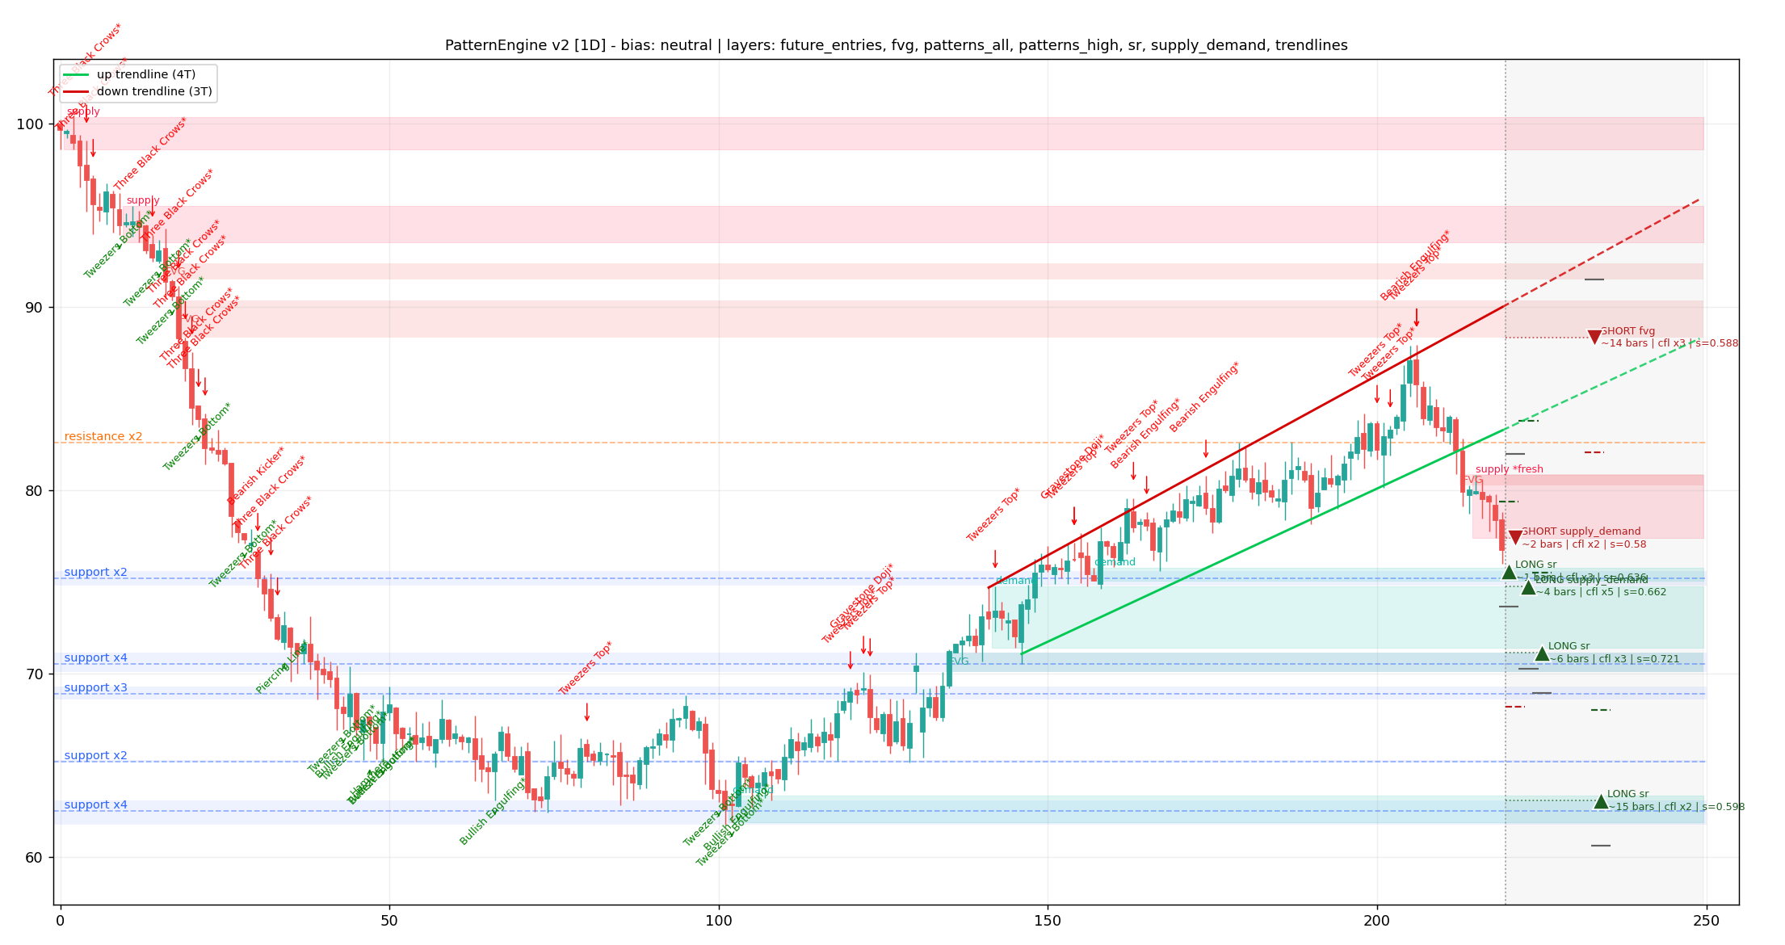
Figure 1 — Working prototype output: candles, S/R zones, demand/supply, fair value gaps, trendlines with future extension, and projected entry markers with stops and targets.

The verdict philosophy: WAIT is a feature
Most trading tools are engagement machines — they nudge the user to act. TradeGuard is the opposite. Statistically, the correct decision on most bars is to do nothing. By making WAIT the celebrated default and quantifying the plan behind it, the app converts impatience (the account killer) into anticipation. Users check the app not to gamble, but to see how close price is to their plan.

The turtle-soup entry: saving money before entry
Named after a classic contrarian technique, the turtle-soup rule exploits the market's habit of running stops just beyond obvious levels before reversing. TradeGuard's alert engine implements it as a state machine: a projected zone must first be TOUCHED, then SWEPT (price wicks beyond the zone edge), then RECLAIMED (a close back inside). Only then does an ENTER verdict fire. The benefits are concrete: the user avoids the common first-touch stop-out, the protective stop sits just beyond the sweep wick instead of beyond the whole zone, and the same account risk therefore buys a better position with a superior reward-to-risk ratio.

The news stand-aside module
The app ingests an economic calendar (e.g. central-bank decisions, inflation and employment releases) plus broker-specific event feeds. Rules are simple and protective: within a configurable window (default 30 minutes) before a high-impact event affecting the instrument, new ENTER verdicts are suppressed, open-alert users are notified, and the chart displays a visible stand-aside banner with the event name and countdown. After the release, scanning resumes once volatility normalizes. For synthetic indices that trade 24/7 without macro events, the module instead flags abnormal volatility spikes.

5. Interface design: web and mobile mockups
The interface follows one rule: the verdict is the hero. Charts, layers and alerts all exist to justify a single, honest recommendation — amber WAIT cards that explain themselves at length, green ENTER cards that are short because the decision is already made. Both clients share this language so a user can move between desktop and phone without relearning anything.

5.1 Web application — the analysis workstation
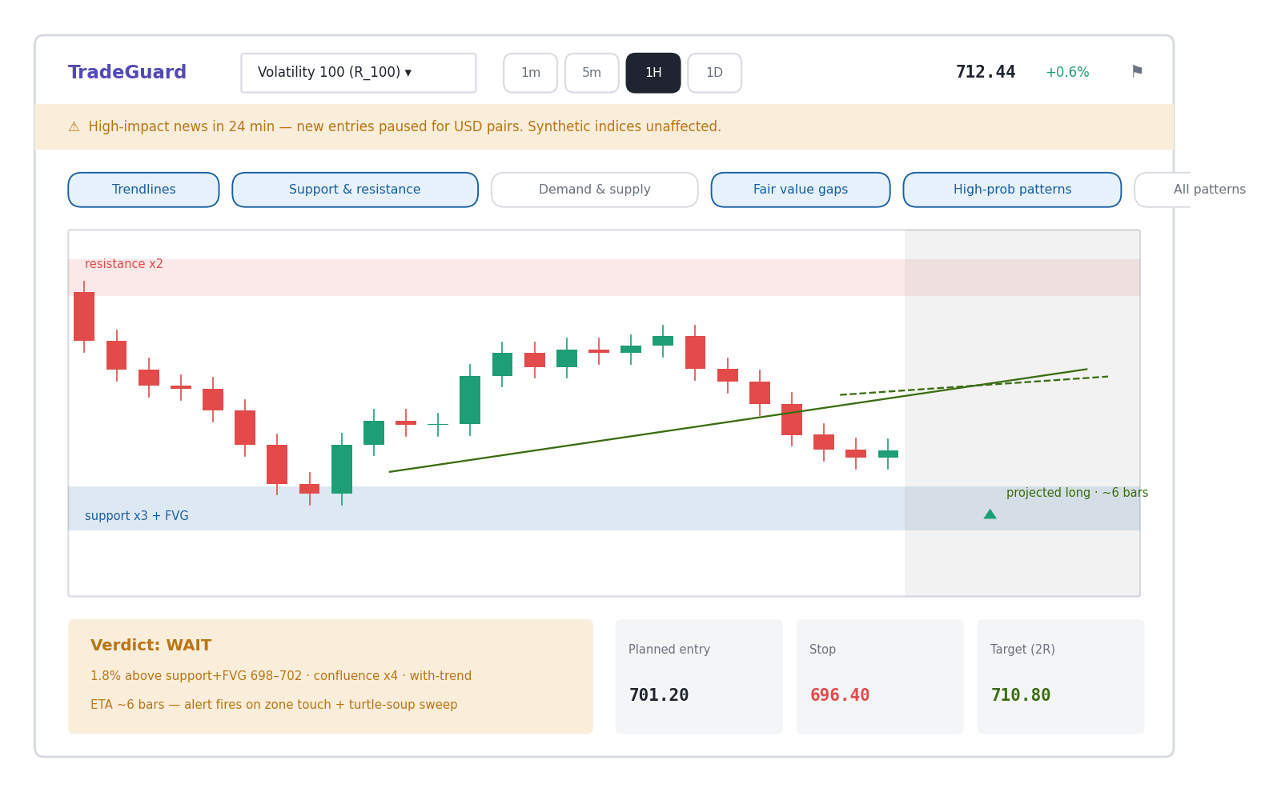
Figure W1 — Web dashboard in the WAIT state. Top bar: pair selector, timeframe pills, live price. The amber news banner is deliberately unmissable. Six layer toggles map one-to-one to the engine's analysis layers. The chart shows the support+FVG zone, resistance band, trendline with dashed future extension, the shaded future region and the projected entry marker. Below: the WAIT card with its reasons beside the pre-computed entry/stop/target.
Design notes: the WAIT card always states the nearest projected zone, the distance from price, the confluence count and the estimated arrival — patience with a plan, not silence. The trade plan (entry, stop, target) is computed and displayed before the trade exists, so the user can pre-approve the risk instead of improvising at the alert.

5.2 Mobile application — the alert companion (four screens)
The Android app is organized around four bottom-navigation tabs: Chart, Alerts, Stats and Settings.
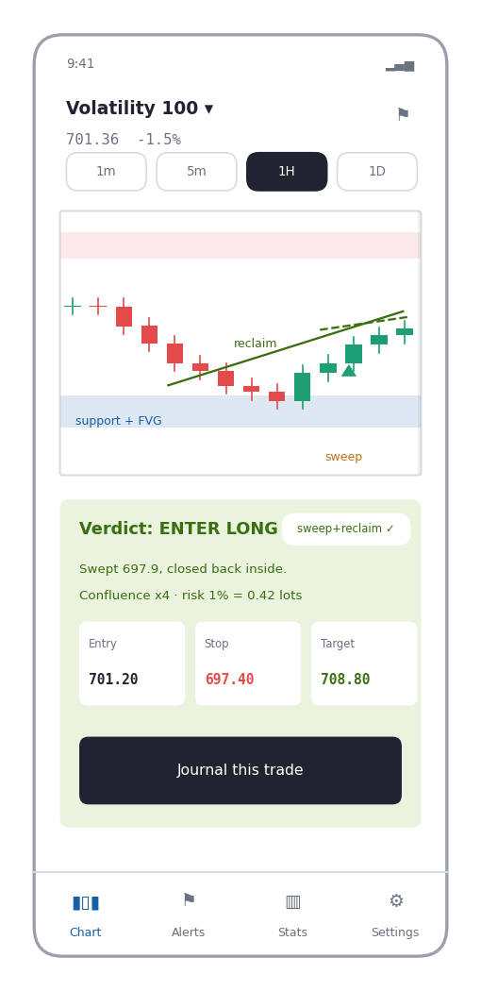  Figure M1 — Chart tab (ENTER state): the sweep below the zone and the reclaim close are marked; the green card carries the confirmed badge, reasoning, sized plan and a journal action. | 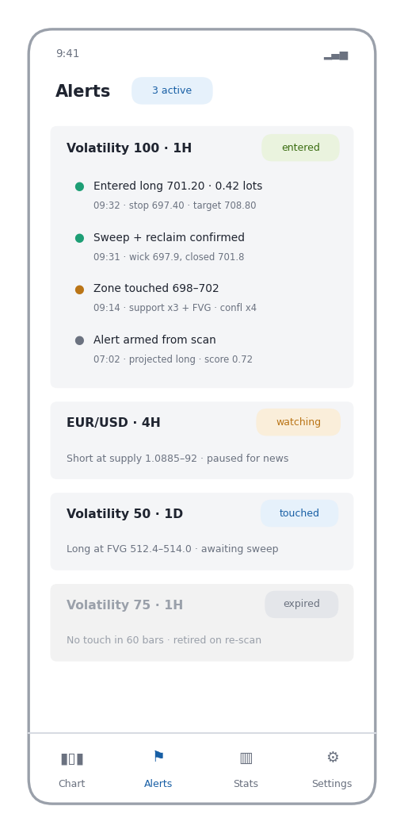  Figure M2 — Alerts tab: each card is one armed zone; the top card expands into the full state timeline (armed, touched, sweep confirmed, entered). A news-paused alert and an expired zone are shown honestly.

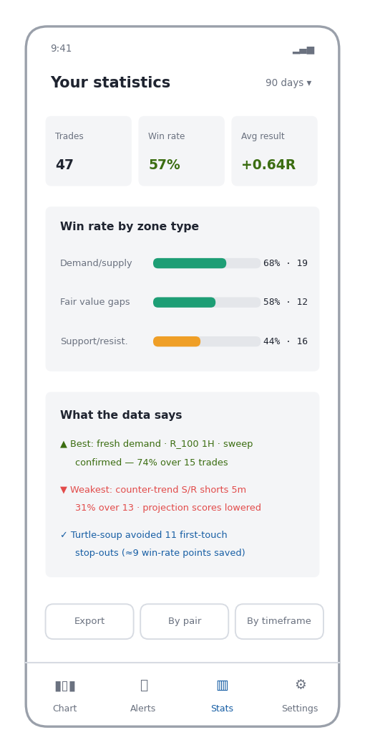  Figure M3 — Stats tab: win rate and average R from the user's own journaled outcomes; win-rate bars per zone type with sample counts; plain-language insights, including what the turtle-soup gate saved. | 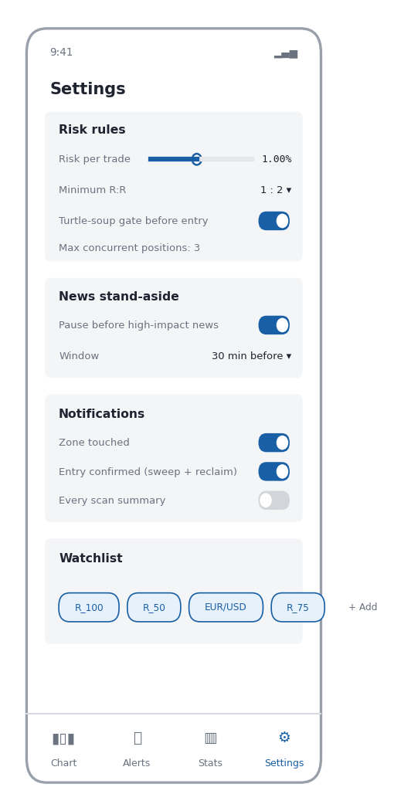  Figure M4 — Settings tab: risk per trade, minimum reward-to-risk, the turtle-soup gate, the news stand-aside window, notification granularity and the watchlist. Rules set here are enforced by the backend, not merely suggested.
A deliberate pairing runs through all screens: WAIT is amber and wordy because it must persuade patience; ENTER is green and terse because only execution details remain. Every state and statistic shown on these screens is read from, or written to, the database described in Section 7.3.

6. How it works: the user journey (UAT flow)
The following flow is both the user journey and the acceptance-test script. Each numbered step has a measurable pass criterion (Section 10).
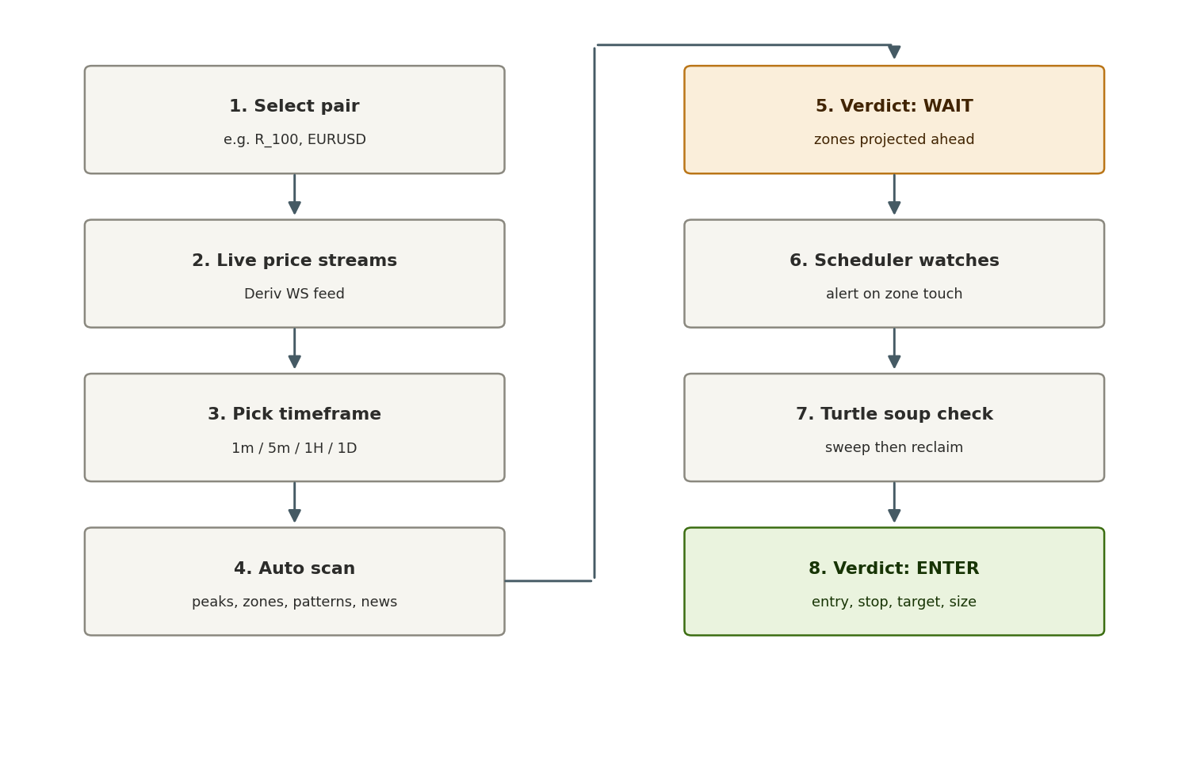
Figure 2 — End-to-end journey: from pair selection to a disciplined, turtle-soup-confirmed entry.
Note the two amber/green gates: step 5 makes patience explicit (the verdict is WAIT while zones are projected ahead), and step 8 can only be reached through the turtle-soup check in step 7. There is no path from “chart looks nice” straight to “enter now” — by design.

7. System architecture
Both clients are deliberately thin. One shared Python backend performs all analysis, so the scan logic exists once, is testable once, and improves for every user simultaneously. The three core backend components already exist as working, tested code:
- Analysis — pattern_engine (v2): scipy-based swing detection, S/R clustering, demand/supply zones, fair value gaps, trendline fitting with future extension, ~20 graded candlestick detectors, confluence-ranked future entry projection, and layer-toggle chart rendering.
- Alerts — alert_engine: a per-zone state machine (WATCHING → TOUCHED → TRIGGERED → FILLED / STOPPED / TARGET, with INVALIDATED and EXPIRED), JSON event stream, re-arm on re-scan. The turtle-soup SWEPT state slots between TOUCHED and TRIGGERED.
- Market data — deriv_feed: a robust Deriv WebSocket client — tick and candle subscriptions, request/response matching, 15-second keepalive, staleness watchdog, exponential-backoff reconnect with full re-subscription, and an in-memory price/candle cache the rest of the system reads.

7.1 Android application
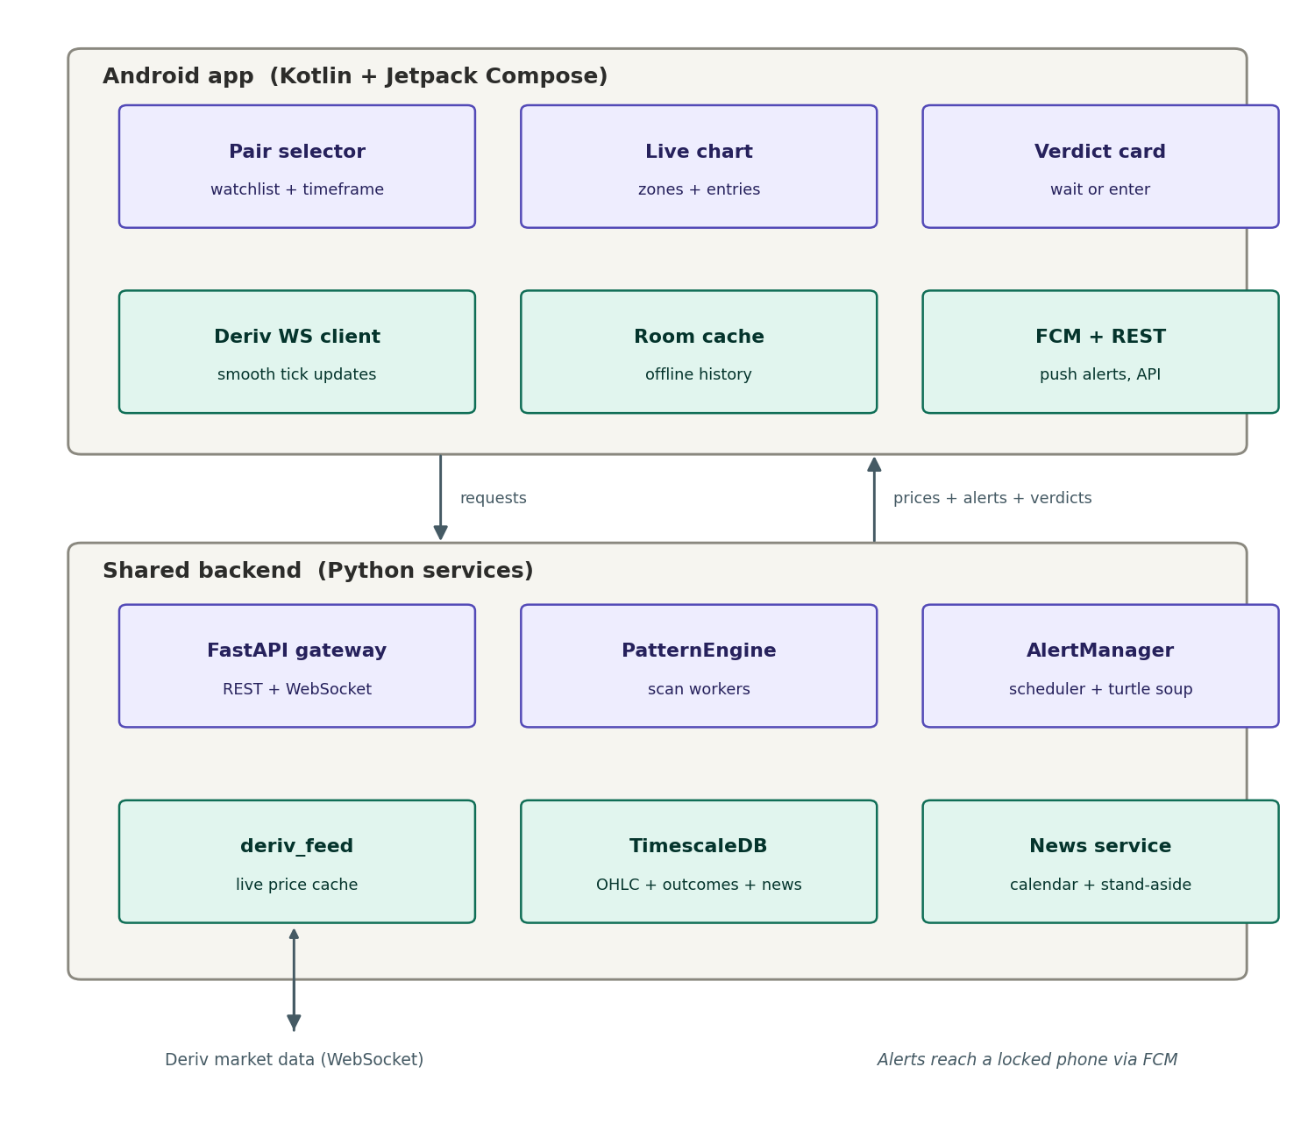
Figure 3 — Android architecture. The app streams ticks directly for a fluid chart, while analysis, scheduling and alert states live in the shared backend. FCM delivers alerts to a locked phone.

7.2 Web application
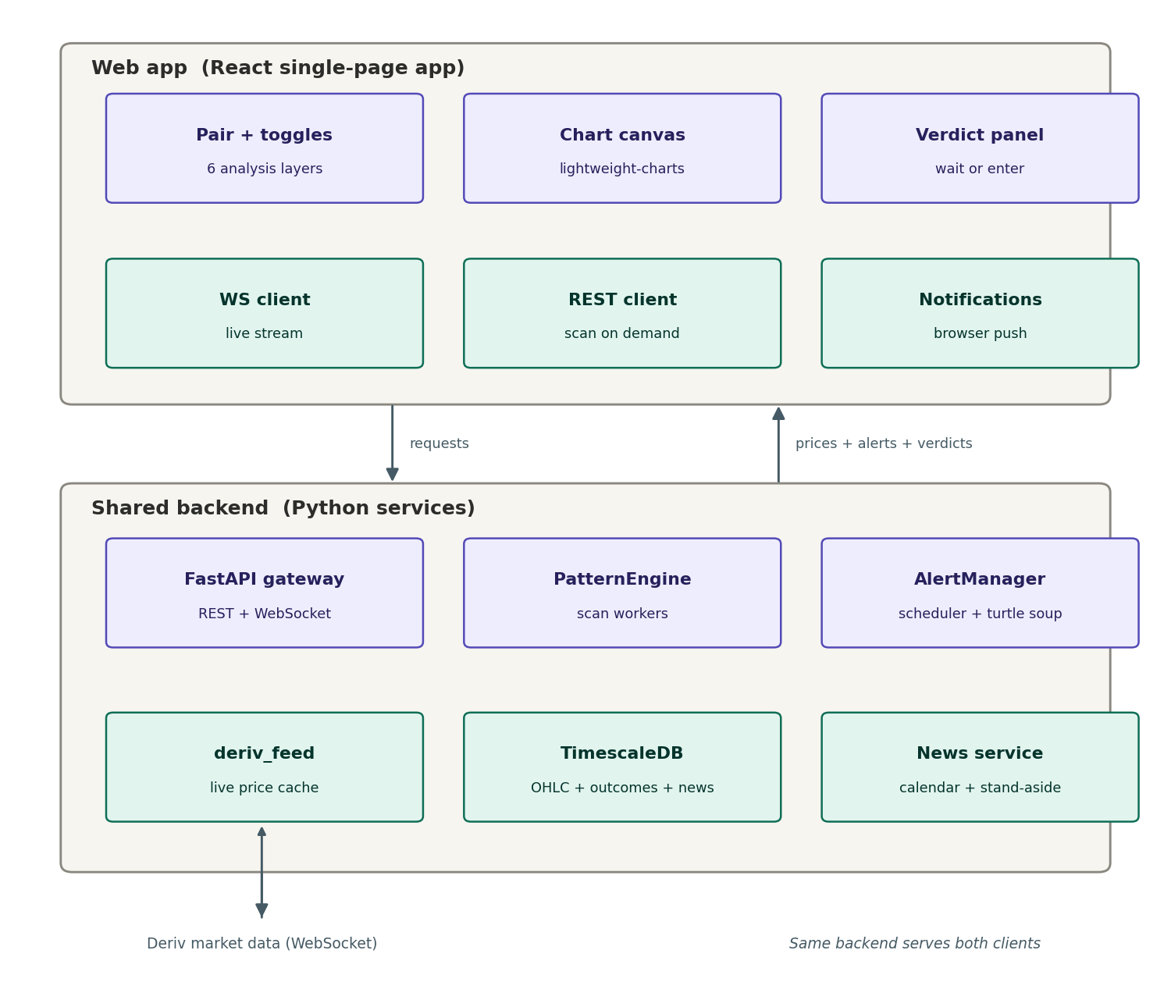
Figure 4 — Web architecture. The React SPA renders the same layers via lightweight-charts; engine output maps directly to chart series, so layer toggles are instant and free.

7.3 How the database is used
TimescaleDB (PostgreSQL with a time-series extension) is the quiet engine behind three of the four app screens. It serves six distinct roles:
- 1. Market-data store and scan cache — Raw OHLC per pair and timeframe is stored once. Each scheduled scan reads the last cached bar, appends fresh ticks from the Deriv feed, and re-analyzes in milliseconds instead of refetching thousands of candles. This is what makes always-on scanning of 20+ pairs across four timeframes affordable, and what makes timeframe switching on the phone feel instant.
- 2. Alert audit trail (Alerts screen) — Every AlertManager state transition (armed, touched, swept, entered, stopped, target, expired) is written as an event row with timestamp, zone details and reasoning. This powers the Alerts screen's timeline — and it is a record no signal seller can fake or delete: if an alert was wrong, the record stays.
- 3. Outcomes journal (Stats screen) — Each closed trade is stored with its full context: zone type, pair, timeframe, confluence score, whether the sweep occurred, and the result in R-multiples. Simple aggregations over this table produce the entire Stats screen — win rate per zone type, best and worst setups, and the measured value of the turtle-soup gate. Nothing is estimated; everything is counted.
- 4. The learning loop (“telling the future better”) — The score that ranks projected future entries starts with fixed weights (confluence 35%, zone quality 35%, trend bias 20%, distance 10%). Once outcomes accumulate, those weights are recalibrated from measured win rates per zone source, per pair, per timeframe — if fresh demand zones on one index hit 74% while counter-trend shorts on 5m hit 31%, the projector boosts the former and suppresses the latter automatically. The system's predictions genuinely improve with every journaled trade. Guardrail: a setup bucket only influences re-weighting after at least ~20 recorded outcomes, because five trades at 80% mean nothing; the Stats screen therefore always shows sample counts next to percentages.
- 5. Settings and rule enforcement (Settings screen) — Risk percentage, minimum reward-to-risk, the turtle-soup toggle, position caps and the news window are stored per user and joined against open positions at verdict time. An ENTER verdict that would breach the 3-position cap simply never fires — the database makes the rules binding rather than advisory.
- 6. News calendar — The economic calendar and event impact ratings are stored and matched to each instrument's currencies, driving the stand-aside banner, the entry pause and the countdown shown in the interface.

Core tables (Phase 1 schema outline)
Table | Key columns | Feeds
candles | pair, timeframe, epoch, o/h/l/c (hypertable) | Charts, scans, backtests
zones | pair, tf, type, min/max, touches, fresh, score | Chart layers, projections
alert_events | alert_id, state, ts, price, reason (append-only) | Alerts screen, audit trail
outcomes | alert_id, zone type, confluence, swept?, result (R) | Stats screen, learning loop
user_settings | user_id, risk %, min RR, caps, news window | Verdict enforcement
news_events | currency, impact, release time, title | Stand-aside module

8. Differentiation: why this beats the alternatives
Alternative | Its weakness | TradeGuard's answer
Signal groups | Opaque, unaccountable, engagement-driven | Every alert shows its logic and is journaled with the outcome
Generic charting apps | Tools without judgement; user still guesses | A verdict layer: WAIT/ENTER with plan, size and reasons
Copy-trading | Blind trust in strangers; hidden drawdowns | User keeps full control and learns the reasoning on every trade
“AI” black-box bots | Unexplainable, over-fitted, often scams themselves | Deterministic, inspectable rules from classical technical analysis plus honest statistics
Account managers | Custody risk; incentive misalignment | No custody ever; the product's incentive is user longevity, not deposits
The deepest differentiator is honesty as a product feature: TradeGuard publishes its own hit rates from the outcomes database, in-app, per user and per setup type. No scammer can match that, because their business depends on hiding exactly this information.

9. Business model and go-to-market

Revenue
Tier | Price (indicative) | Includes
Free | $0 | 1 pair, 1 timeframe, delayed scan, watermark chart, education content
Standard | $7–10 / month | 5 pairs, all timeframes, live alerts, turtle-soup gate, news stand-aside
Pro | $20–25 / month | Unlimited pairs, multi-timeframe confluence, outcomes analytics, API export
Optional later streams: broker-affiliate revenue (only with regulated partners and full disclosure), and a B2B white-label of the analysis API for brokers who want to offer honest tooling to reduce client churn.

Go-to-market
- Launch where the pain is loudest: communities of Deriv synthetic-index traders (24/7 markets, mobile-first, heavily targeted by scammers today).
- Content marketing that exposes scam mechanics and demonstrates the app's transparent alternative — every exposé doubles as product education.
- A public, read-only “verdict feed” showing recent WAIT/ENTER calls with outcomes — radical transparency as acquisition.
- Partnerships with legitimate trading educators who want tooling that reinforces (rather than replaces) discipline.

10. Acceptance criteria (UAT plan)
Step | Scenario | Pass criterion
1 | User selects a pair from the watchlist | Chart context loads; last session's layers restored
2 | Live price streaming | First tick within ~1s; survives forced disconnect via auto-reconnect; stale-feed watchdog recovers without user action
3 | Timeframe switch | Candles for the new timeframe render < 2s from cache/DB
4 | Auto scan | Scan completes < 3s; only toggled layers render; every zone/pattern lists its reason on tap
5 | WAIT verdict | Card states nearest projected zone, distance, confluence and ETA; no ENTER shown
6 | Scheduler + zone touch | Push notification arrives on a locked phone when price enters a projected zone
7 | Turtle-soup gate | No ENTER verdict without a recorded sweep-beyond-zone and reclaim close; stop is placed beyond the sweep wick
8 | ENTER verdict | Entry, stop, target and position size displayed; trade auto-journaled to outcomes table
News | High-impact event within window | ENTER suppressed; stand-aside banner with countdown; resumes after release
Stats | User opens performance screen | Win rate and average R shown per zone type, per pair, from real journaled outcomes

11. Roadmap
Phase | Deliverables | Status / timeline
0 — Engine | pattern_engine v2, alert_engine, deriv_feed, backtest harness | BUILT and tested (prototype)
1 — Backend | FastAPI gateway, TimescaleDB schema, scheduler, news service, turtle-soup state | Months 1–2
2 — Web app | React SPA, lightweight-charts layers, verdict panel, browser push | Months 2–4
3 — Android | Compose UI, Room cache, FCM alerts, Play Store beta | Months 3–5
4 — Learning loop | Outcomes analytics, score re-weighting, public verdict feed | Months 5–6
5 — Scale | More instruments/brokers, iOS, B2B API | Month 6+

12. Risks, ethics and compliance
- Not financial advice, no custody — TradeGuard is an analysis and education tool. It never holds funds, never trades on a user's behalf, and every verdict screen carries a clear risk disclosure. This is both an ethical stance and the key regulatory simplifier.
- Honest marketing — No profit promises, ever — the anti-scam positioning collapses the moment the product over-claims. Marketing is reviewed against this rule.
- Model risk — Technical analysis is probabilistic; losing streaks happen. Mitigation: enforced fractional risk sizing, WAIT-by-default, published statistics, and drawdown warnings.
- Vendor risk — Dependence on Deriv's API is mitigated by the feed's clean abstraction — additional broker feeds are adapters, not rewrites.
- Regulatory — Jurisdictional rules on trading tools vary; launch sequencing includes legal review per market, and the education-first framing keeps the product outside advisory licensing in most jurisdictions.

13. Conclusion and the ask
The market does not need another promise of easy money — it needs protection from those promises. TradeGuard turns the tools scammers pretend to have into software any trader can verify: transparent structure detection, projected entries, patient alerts, a fake-out-resistant entry method, news protection, and honest statistics. The analysis core is already built and demonstrably working; what remains is productization.
We are seeking a partner to fund and support Phases 1–3 (backend, web and Android, approximately six months to public beta), in exchange for equity participation to be discussed. The team will demonstrate the live prototype — engine, alerts and market feed — on request.
Small wins, a great plan, and no one else's hands on the account. That is the product.

